Department of Computer Science and Engineering

Compiler Design Lab (CS 306L)

Week 2: Symbol Table Implementation

G.JASHIT

AP21110010921

CSE-O

1. Symbol table is an important data structure created and maintained by compilers in order to store information about the occurrence of various identifiers such as variable names, function names, objects, classes, interfaces, etc. Symbol table is used by both the analysis and the synthesis parts of a compiler. Symbol table can be implemented in one of the following ways:

• Linear (sorted or unsorted) list

• Binary Search Tree

• Hash table

• And other ways.

OUTPUT:

* Using Hash Table

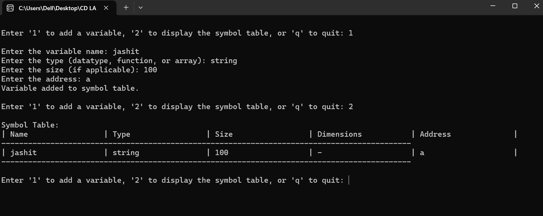

By Using Hash Table we have implemented this code first we need to enter the variable name,datatype,size,address.If it is the Function we need to mention the dimension of the code.

* Using LinkedList

